For my Project submission, I have chosen the **Hotel Assistant** scenario for Tripleten AI Automation Sprint 2.

**Project Goal:**

The objective was to develop a practical and user-centric chatbot for the "Triple Peaks Hotel," utilizing a provided FAQ document as its knowledge base. This scenario was selected due to its representation of a common real-world application of chatbot technology, where the provision of immediate and accurate answers to frequently asked questions can significantly improve customer experience.

**Hotel Assistant Bot:**

[Link to Hotel Assistant Bot](https://hotel-assistant-54ea6d.zapier.app)

**Screenshots of Conversations**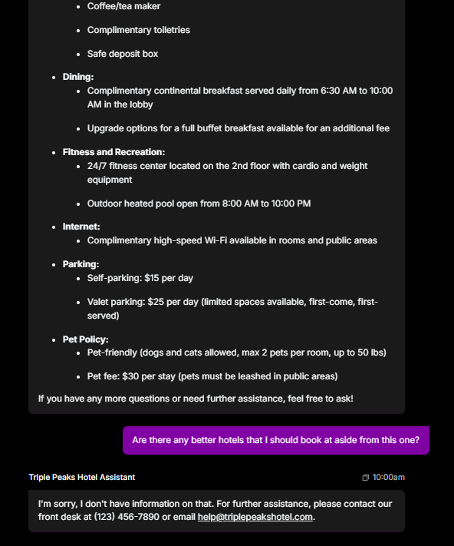

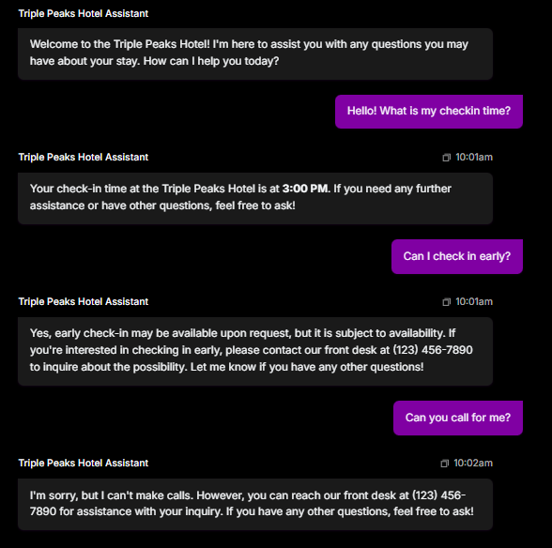

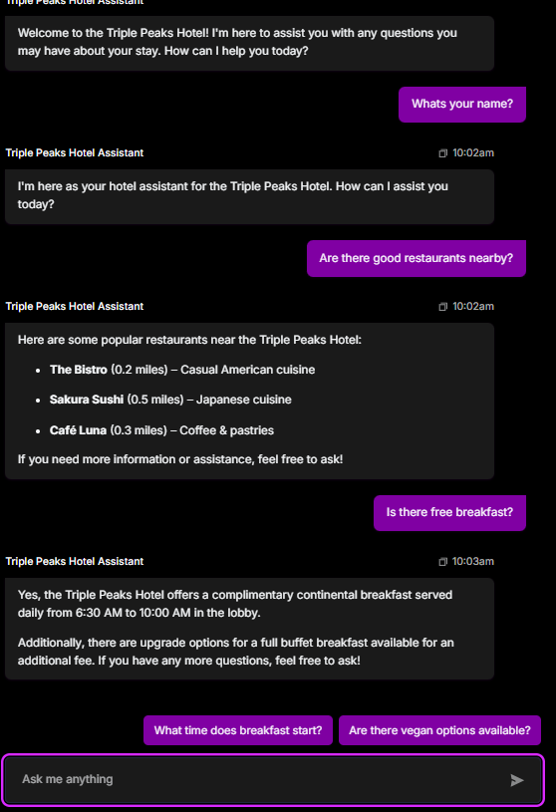

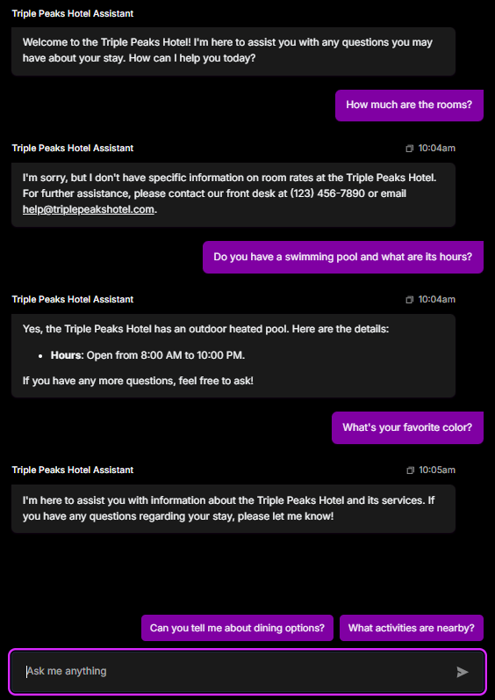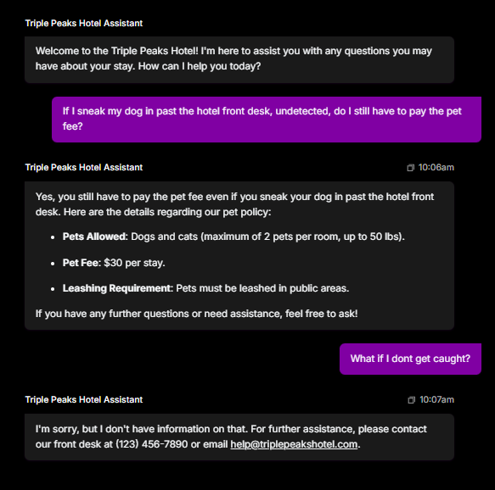

**Bot Settings Used:**